4. SIMULATION OF NEURAL NETWORK BASED EQUALIZER

4.1 Overview

There are number of the equalization methods and they are applied in civil, military, industrial and communication equipments and apparatus. Commonly used linear equalization methods are used to compensate linear channel distortion. One of the methodologies that are used for equalization on nonlinear communication channel is Neural Network. Nonlinear equalizers can outperform the linear equalizers and compensate all linear, nonlinear and additive channel distortion. In this thesis the development of nonlinear adaptive equalizer based on neural network (NN) is considered.

4.2 Minimum and Non-minimum Phase Channels

Assume that we have the magnitude of the frequency of a filter and tried to use that directly to implement a frequency domain filter. The corresponding impulse would be a zero phase filter with an impulse response that is symmetric around t=0 because the impulse response is non-zero for t<0, such a filter is non-casual. If one needs to implement a filter that is casual, then we must create a phase function to go with magnitude frequency response. The lowest magnitude phase function that produces a casual filter for a given magnitude frequency response gives us a "minimum phase" filter. Such a filter is also the casual filter with the lowest group delay at each frequency.

The real and imaginary parts of the frequency response of a minimum phase filter cannot be chosen independently. They are related by the Hilbert transform.The Hilbert Transform was largely forgotten after its original publication. However, it was reintroduced to the modern era of signal processing by Norbert Wiener.

When all the root of the model z-transform lie within the unit circle, the channel is termed minimum phase, the inverse of a minimum phase channel is convergent, illustrated by Equation 4.1:

$\begin{aligned}H(z)=1\text{.}0+0\text{.}5z^{−1} \\ \frac{1}{H(z)}=1\begin{aligned}\frac{1\text{.}0+0\text{.}5z^{−1}}{=\sum_{ı=0}^{∞}{\left(−\frac{1}{2}\right)z^{−ı}}}\end{aligned}\end{aligned}$ =1-0.5z⁻¹+0.25z⁻²-0.125^{z-3}……….
(4.1)

where as the inverse of non-minimum phase channels are not convergent, as shown in Equation 4.2.
$\begin{aligned}H(z)=1\text{.}0+0\text{.}5z^{−1} \\ \frac{1}{H(z)}=\frac{z}{1\text{.}0+0\text{.}5z} \\ z\text{.}\left[\sum_{ı=0}^{∞}{{\left(−\frac{1}{2}\right)}^{ı}z^{ı}}\right]\end{aligned}$ = z. [1-0.5z+0.25z²-0.125z³ …….]
(4.2)

Since equalizers are designed to invert the channel distortion process they will in effect model the channel inverse. The minimum phase channel has a linear inverse model therefore a linear equalization solution exists. However, limiting the inverse model to m-dimensions will approximate the solution and it has been shown that non-linear Solutions can provide a superior inverse model in the same dimension.

A linear inverse of a non-minimum phase channel does not exist without incorporating time delays. A time delay creates a convergent series for a non-minimum phase model, where longer delays are necessary to provide a reasonable equalizer. Equation 4.3 describes a non-minimum phase channel with a single delay inverse and a four sample delay inverse. The latter of these is the more suitable form for a linear filter.

$$\begin{aligned}H(z)=0\text{.}5+1\text{.}0z^{−1} \\ z^{−1}\text{.}\frac{1}{H(z)}=\frac{1}{1\text{.}0+0\text{.}5z}=1−0\text{.}5z+0\text{.}\text{25}z^{2}−0\text{.}\text{125}z^{3} \\ z^{−1}\frac{1}{H(z)}=1−0\text{.}5z^{2}−0\text{.}\text{125}z^{3}\text{.}\text{.}\text{.}\text{.}\text{.}\text{.}\text{.}\text{.}\text{.}\text{.}\text{.}\text{.}\text{.}\text{.}\text{.}\text{.}\text{.}\text{.}\text{.}\text{.}\text{.}\text{.}\text{.}\text{.}\text{.}\text{.}\text{.}\text{.}\text{.}\text{.}\text{.}\text{.}\text{.}\text{.}(\text{non}−\text{causal}) \\ z^{−4}\frac{1}{H(z)}=z−3−0\text{.}5z^{−2}+0\text{.}\text{25}z^{−1}+0\text{.}\text{125}\text{.}\text{.}\text{.}\text{.}\text{.}\text{.}\text{.}\text{.}\text{.}\text{.}\text{.}\text{.}\text{.}\text{.}(\text{truncated}−\text{and}−\text{casual})\end{aligned}$$
(4.3)

The three-tap non-minimum phase channel H(z) =0.3484 + 0.8704z⁻¹+0.3484z⁻² is used throughout this thesis for simulation purposes. A channel delay, D, is included to assist in the classification so that the desired output becomes u (n-D). Delays of D=0 and D=1 are examined. The delay D=0 is used to demonstrate the divisions that can be observed in the two equalization classes, which cannot be classified with a linear decision and the Delay D = l, which is required to construct a linear equalizer for a non-minimum phase channel, is used to demonstrate the non-linear bit-error rate (BER) performance advantages over n linear equalizer.

Figure 4.1 shows the symbol points of this model, where each symbol corresponds to a channel input data sequence that can be observed at the receiver. Table 4-1 lists these input sequences and gives the expected receiver sample in each case for a noiseless channel. These receiver samples define the channel symbol coordinates in the diagram of Figure 4.1. The number of observable symbols within a system is 2^{n+m-1}, where there are m observed channel outputs in the sample vector, Y(n). Hence for a three-tap model in two-dimensional space, with two successive channel outputs forming the input vector Y(n)=[y(n), y(n-l)]. There are sixteen individual symbols, eight that correspond to a negative class and eight to a positive class (Table 4-1). It can be seen from Figure 4.1 that the symbol classes of the non-minimum phase channel without a delay cannot be separated with a single linear boundary but can be when the output is delayed
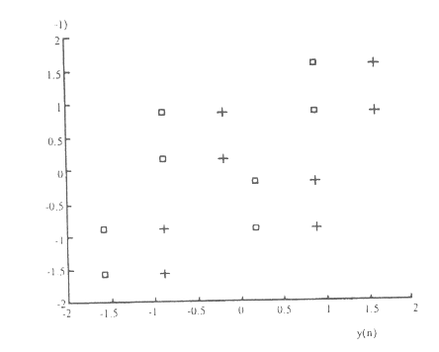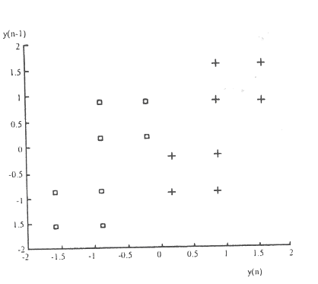
(a) (b)

Figure 4.1 Three-tap channel model symbol points seen in a two-dimensional observation space. H (z) = 0.3482+0.8704z⁻¹+0.3482z⁻². (a) Delay D=0 (b) Delay D=l.

Table 4-1 Channel symbol input combinations and received samples for the
H(z) =0.3482+0.87042z⁻¹+0.3482z⁻² model, where the sample vector, Y, is (the position of the symbols in m-dimensional space m=2)

Received sample vector, y(n).

Input combinations

u(n) | u(n-l) | u(n-2) | u(n-3) | y(n) | y(n-l)
1 | 1 | 1 | 1 | 1.57 | 1,57
1 | 1 | 1 | -1 | 1.57 | 0.87
1 | 1 | -1 | 1 | 0.87 | -0.17
1 | 1 | -1 | -1 | 0.87 | -0.87
1 | -1 | 1 | 1 | -0.17 | 0.87
1 | -1 | I | -1 | -0.17 | 0.17
1 | -1 | -1 | 1 | -0.87 | -0.87
1 | -1 | -1 | -1 | -0.87 | -1.57
-1 | 1 | 1 | 1 | 0.87 | 1.57
-1 | 1 | 1 | -1 | 0.87 | 0.87
-1 | 1 | -1 | 1 | 0.17 | -0.17
-1 | 1 | -1 | -1 | 0.17 | -0 87
-1 | -1 | 1 | 1 | -0.87 | 0.H7
- 1 | -1 | 1 | -1 | -0.87 | 0.17
-1 | -I | -1 | 1 1 | -1.57 | -0.87
-1 | -1 | -1 | -1 | -1.57 | -1.57

4.3 LMS Linear Equalizer

Figure 4.2(a) shows the structure of linear equalization system. Realization of this system using Matlab Simulink is given in Figure 4.2(b). This example illustrates the usage of an LMS linear equalizer. The simulation transmits a 16-QAM signal, modeling the channel using an FIR filter followed by additive white Gaussian noise. The equalizer receives the signal from the channel and, as training symbols, a subset of the modulator's output. The equalizer operates in training mode at the beginning of each frame and switches to decision-directed mode when it runs out of training symbols. the signals before and after equalization to illustrate the effect of the equalizer.
+
+
Channel
Σ
s (k)
LMS Equalizer

n (k)
x(k)
z⁻¹

z⁻²
z^{-m}
. . .
x(k-1)
x(k-2)
x(k-m)
-

a)
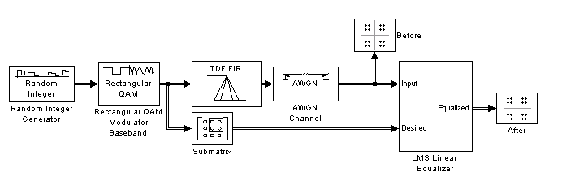
b)
Figure 4.2 (a) Structure of LMS equalizer system,(b) Simulation LMS Linear Equalizer
To build the model, gather and conFigure these blocks:
Random Integer Generator. Set parameters as:
- Set M-ary number to 16.
- Set Sample time to 1/1000.
- Select Frame-based outputs.
- Set Samples per frame to 1000.

Rectangular QAM Modulator Base band. Set parameters as:
- Set Normalization method to Average Power.
- Set Average power to 1.

Digital Filter. Set parameters as:
- Set Transfer function type to FIR (all zeros).
- Set Filter structure to Direct form transposed.
- Set Numerator coefficients to [1 -.3 .1 .2j].

Sub matrix. Set Indexing sub library of Signal Management
- Set Ending row to Index.
- Set Ending row index to 100.

AWGN Channel. Set parameters as:
- Set Mode to Signal to noise ratio (SNR).
- Set SNR to 40.

LMS Linear Equalizer. Set parameters as:
- Set Number of taps to 6.
- Clear the check boxes labeled Mode input port, Output error, and Output weights.
Two copies of Discrete-Time Scatter Plot Scope, in the Comm Sinks library
- Set Points displayed to 400 in each of the two copies.

Connect the blocks as in the Figure 4.3. Running the simulation produces two scatter plots that display the signal before and after equalization, respectively.
.

Throughout the simulation, the signal before equalization deviates noticeably from a 16-QAM signal constellation.

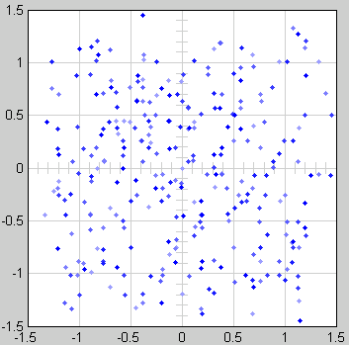
Figure 4.3 (a) Outputs for LMS equalizer

Early in the simulation, the equalizer does not appear to improve the scatter plot. In fact, the equalizer is busy trying to adapt its weights appropriately. As shown in figure Figure 4.3 (b) the equalized signal very early in the simulation.
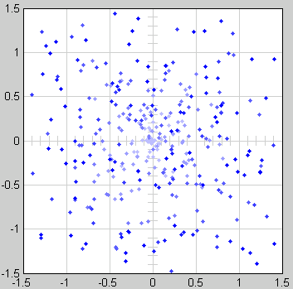
Figure 4.3 (b)

After some simulation time passes, the equalizer's weights work well on the received signal. As a result, the equalized signal looks far more like a 16-QAM signal constellation than the received signal does. As shown in Figure 4.3 (c) the equalized signal in its steady state.

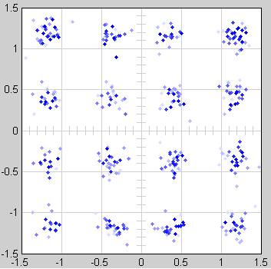
Figure 4.3 (c)

4.4 Simulation Of Adaptive Equalizers

4.4.1 Structure of Adaptive Equalization System

The structure of typical adaptive equalization system is given in Figure 4.4. s(k) is the transmitted symbol stream, n(k) is the additive noise, Gaussian distributed. The channel may be linear and non-linear. For linear channel linear adaptive equalizer, for nonlinear channel nonlinear adaptive equalizer is used. The input-output symbol sequence map is assumed to be unambiguous. In modern interference-limited cellular telephony systems, the main error source is the inter-symbol interference (ISI), rather than the thermal noise.

+
+
Channel
Σ
s (k)
Adaptive Equalizer

n (k)
x(k)
z⁻¹

z⁻²
z^{-m}
. . .
x(k-1)
x(k-2)
x(k-m)
Σ
e (k)
-
delay
Channel medium

Figure 4.4 Structure of neural equalization system

The ISI consists in the spreading of symbol information through subsequent signal samples, and is the main problem in the relatively high SNR, typical of most existing transmission systems.

The purpose of the equalizer is to estimate s(k), minimizing the combined effects of ISI and noise. In particular, the adaptive equalization system makes use of a set of delayed input samples and past detected symbols.

Least mean square (LMS) algorithm, Recursive Least-square (RLS) algorithm, Neural Networks. They can be successfully applied to the adaptive equalization of digital communication channels. NNs are able to yield significant Performance when little information is available on the channel model. This fact can be explained by the very general assumptions made on the mapping from the received signal to the output symbol space that recast the demodulation problem as a classification task.

The proposed neural network is considerably simpler and faster than existing structures, being composed of a two-layer perception. This architecture can be viewed as a NN. Samples contained in both the input and tapped delay lines (DLs) constitute the inputs to the first neuron layer. During the learning phase, DL is fed by an internal replica of the transmitted preamble sequence.

The weight updating is made by the Block Recursive Least Squares (BRLS) algorithm. This approach searches consistently for a local minimum of the error functional in a Newton-like fashion, thus allowing for a super linear convergence rate. The choice of the cost functional should be related to the concept of equalization as a classification problem, where the objective is the separation of clusters generated by mapping the transmitted symbols through the channel input-output relationship.

In typical applications, an equalizer begins by using a known sequence of transmitted symbols when adapting the equalizer weights. The known sequence, called a training sequence, enables the equalizer to gather information about the channel characteristics. After the equalizer finishes processing the training sequence, it adapts the equalizer weights in decision-directed mode using a detected version of the output signal. To use a training sequence when invoking the equalize function shown in Figure 4.5; include the symbols of the training sequence as an input vector.

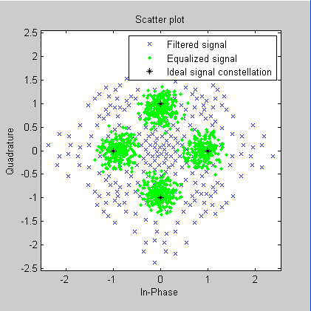
Figure 4.5 Output of adaptive equalization system

4.4.2 Adaptive LMS and RLS Equalizers

If our data is partitioned into a series of vectors (that we process within a loop), then we can invoke the equalize function multiple times, saving the equalizer's internal state information for use in a subsequent invocation. In particular, the final values of the weight inputs and weight properties in one equalization operation should be the initial values in the next equalization operation, as shown in Figure 4.6.

The illustrates how to use equalize within a loop, varying the equalizer between iterations. This discussion presents it in these steps:
- Initializing Variables
- Simulating the System Using a Loop

If we want to equalize iteratively while potentially changing equalizers between iterations, then the procedure help us generalize to other cases.

1. Initializing Variables. The beginning of the program defines parameters and creates three equalizer objects:
- An RLS equalizer object.
- An LMS equalizer object.
- A variable, eq_current, that points to the equalizer object to use in the current iteration of the loop. Initially, this points to the RLS equalizer object. After the second iteration of the loop, eq_current is redefined to point to the LMS equalizer object.

2. Simulating the System Using a Loop. The next portion of the program is a loop that
- Generates a signal to transmit and selects a portion to use as a training sequence in the first iteration of the loop
- Introduces channel distortion
- Equalizes the distorted signal using the chosen equalizer for this iteration, retaining the final state and weights for later use
- Plots the distorted and equalized signals, for comparison
- Switches to an LMS equalizer between the second and third iterations

The produces one scatter plot for each iteration Figure 4.7, indicating the iteration number and the adaptive algorithm in the title. A sample plot is below. Our plot might look different because the program uses random numbers.
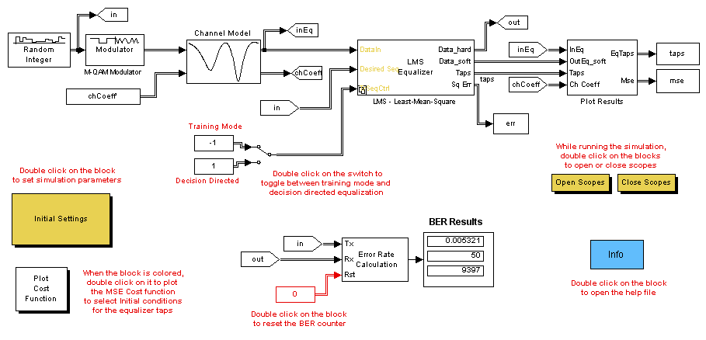
Figure 4.6 Simulation of Adaptive equalization using LMS

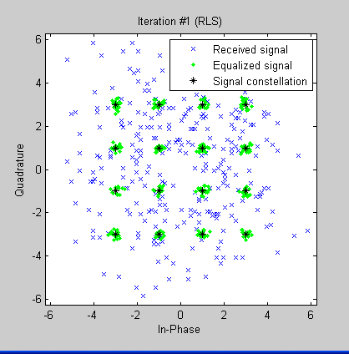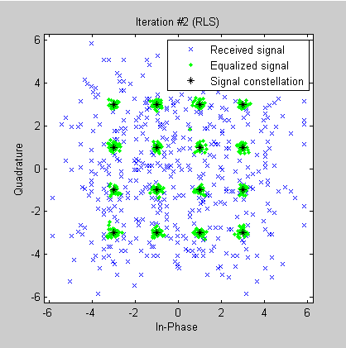

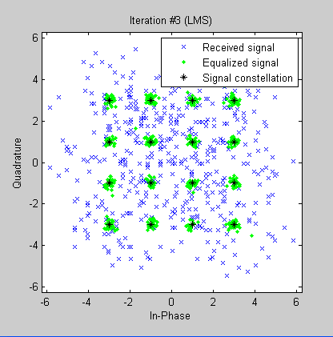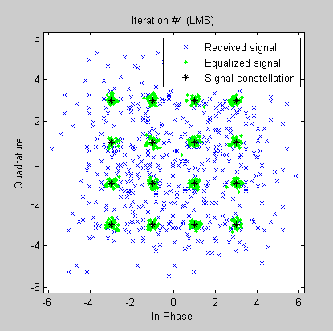
Figure 4.7 The Outputs of Simulation For RLS and LMS

4.5 Simulation of Neural Equalizer

Structure of neural network for channel equalization is given in Figure 4.8. The output of the channel is input of the equalizer. Assume that input signals applied to the network at time n are x_{i}(n) (i=1..N). Output signal of the network are y(m). N and M number of neurons in the input and output layers, correspondingly. In this case the number of output neuron M=1. The network is interconnected with W weight coefficients. The output signal of network is defined by the following equation.
Y =f(X, W) (4.4)
Here X and W are external input signals and weight coefficients of network correspondingly, f is activation function. In the work the Gaussian activation function is used.

y(n)
x_{N}(n)
x₂(n)
x₁(n)
y(n-1)
w_{ik}
w_{kj}
y_{k}(n)

•

•

•

Figure 4.8 Neural Network Structures

The above described neural network structure is used in equalizer for equalization channel distortion. Structure of equalization system is given in Figure 4.8.

Start
Generation of input finally signal for channel translation

Input of signal and preparing the modulation input signal for channel
Testing number of signal
END
Calculating the output of channel
Adding noise to the signal
Deigning input signal for equalizer
Calculating output equalizer
Calculating error on the output of the equalizer
Training network auditions
No
Yes

First the input signals are generated. This input signals are given to the channel input. The additive noise is added to the transmitted signal. Output of channel is input for the equalizer. On the output of equalizer the deference (error) between equalizer output and desired signal is determined. Using this error, the training of the coefficients of neural network equalizer is carried out.

The simulation of equalization system is carried out for the channel y(t) = 0.3484+0.8704z⁻¹ +0.3484z⁻² in presence of additive distortions.

The neural network equalizer is trained to equalize the distortion.

4.6 Simulation

During simulation the transmitted signals s(k) are input known samples with an equal probability of being –1 and 1. These signals are corrupted by additive noise n(k). The corrupted signals are inputs for equalizer. In channel equalization, the problem is the classification of coming input signal of equalizer onto feature space which is divided into two decision regions. R⁺ and R⁻.Here R⁺={x(k)⏐s(k)=1} and R⁻={x(k)⏐s(k)=-1}, x(k) is channel output signal.

The NN structure and its training algorithm are used to design equalizer for equalization of channel distortion. The simulations have been carried out for equalization of linear and nonlinear channels.
In simulation the following channel model is used.
$$x(k)=0\text{.}\text{3482s}(k)+0\text{.}\text{8704s}(\text{k-1})+\text{ 0}\text{.}\text{3482s}(\text{k-2})+n(k)$$ | (4.5)

During equalizer design the sequence of transmitted signals are given to the channel input. The transmitted data sequence s(k) consists of 200 symbols. They are assumed to be an independent sequence taking values from {-1,1} with equal probability. The additive Gaussian noise n(k) is added to the transmitted signal. In the equalizer-output the deviation of target transmitted signal from the current equalizer output is determined. This error e(k) is used to adjust network parameters. Training is continued until the value of error for all training sequence of signals would be acceptably minimum.

During simulation the input signals for equalizer are outputs of channel x(k), x(k-1), x(k-2), x(k-3). The simulation is performed by using NN and well known LMS structure [3]. Both simulations have been performed using the same of initial conditions. During simulation 16 rules are used in equalizers. The learning of equalizers has been carried out. The learning is performed for 1000 iterations. In the result of simulation the performance characteristics (Bit error rate versus signal-noise ratio) for equalizers have been determined. Bit error rate (BER) versus signal-noise ratio (SNR) characteristics have been obtained for different noise levels. Figure.4.9 illustrates the curves that describe the performance analysis of equalizers based on NN and LMS for channel (Equation (4.4)). Here solid line is the performance of NN equalizer, dashed line is the performance of equalizer based on LMS. As shown from Figure performance of NN based equalizer is better than equalizer based on LMS.
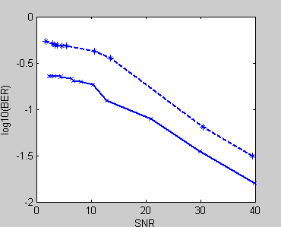
Figure 4.9 Performance of NN (solid line) and LMS (dashed line) equalizers for channel (Equation (4.4))

In Figure 4.10 error plot of learning result of NN equalizer is given. The channel states are plotted in Figure 4.11 Here Figure 4.11 demonstrates noise free channel states, 4.11(b) is channel states with additive noise, and Figure 4.11(c) and 4.11(d) are channel states after equalization of distortion. 4.11(c) describes the simulation result after 500 learning iterations, 4.11(d) the simulation result after 1000 learning iterations. The obtained result satisfies the efficiency of application of NN technology in channel equalization.
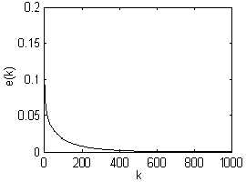
Figure 4.10 Error plot
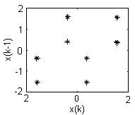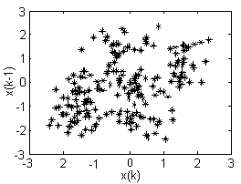
(a) (b)
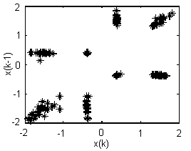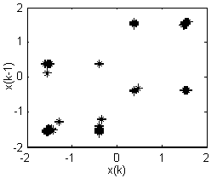
(c) (d)
Figure 4.11 Channel states: (a) noise free, (b) with noise, (c) after equalization (after 500 learning iterations), (d) after equalization (after 1000 learning iterations)

4.7 Summary

This chapter describes the development and computer modeling of adaptive equalization systems. An equalizer is designed using a neural network. The experimental result was demonstrating the successful implementation of the developed method.
Conclusion
In digital communications, channels are affected by both linear and nonlinear distortion, such as intersymbol interference and channel noise. Linear equalizers could not reconstruct the transmitted signal when channels have significant non-linear distortion. When a channel has time-varying characteristics and the channel model is not precisely known, adaptive equalization is applied. One of the effective ways for development of adaptive equalizers for nonlinear channel is the use of neural network.

In this thesis the development of adaptive equalizer based on Neural Network is considered. The structure of adaptive equalization system is given. The functions of main components of equalization system are explained. The characteristics of distortion, interferences and channel noises are explained. Adaptive equalization using least mean square algorithm and neural network are considered.

The operation principle and learning algorithm NN equalizer is described. The NN and its learning algorithm are applied for equalization of the linear and nonlinear channels in presence of additive distortion. Simulation is performed using Matlab package. Simulation results of NN based equalizer demonstrate that the NN equalizer can be trained in short time and it has good BER performance than LMS equalizer. Comparative simulation results satisfy the efficiency of application of the NN in adaptive channel equalization.

